**Institute of Engineering & Technology**

**Devi Ahilya Vishwavidyalaya, Indore (M.P)**

**Department of Computer Science & Engineering**



**Hands-on Android Programming (CER4L2)**

**Android Assignments**

**Submitted To: Submitted By:**

**Er. Shyam Maheshwari Sir Tanishq Chauhan(21C4184)**

**CS-Dept CS “B” 2nd Year**

**IET-DAVV**

**Assignment-1**

1. **Familiarity with ANDROID SDK (Installation and Configuration) and write a hello world program and display on simulator and mobile.**
2. **You have to search “Download Android Studio” on Google**
3. **Or you can also go on this URL to download Android Studio**

[**URL:-**](URL:-)[**https://developer.android.com/studio**](https://developer.android.com/studio)

1. **When you search this… You will see this below page**

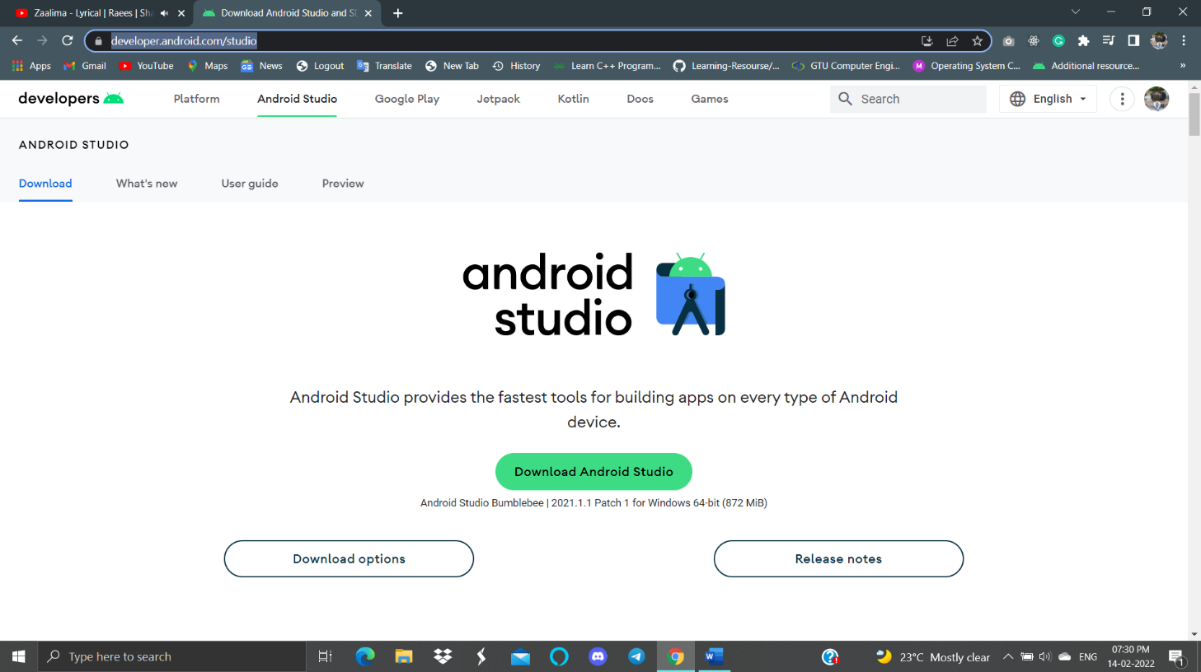

1. **From here you can download the “Android Studio” according to your system.**
2. **After the installation and some configuration and updation.**
3. **Create a New Project**
4. **Choose the Basic Activity of the Project (if you want)**

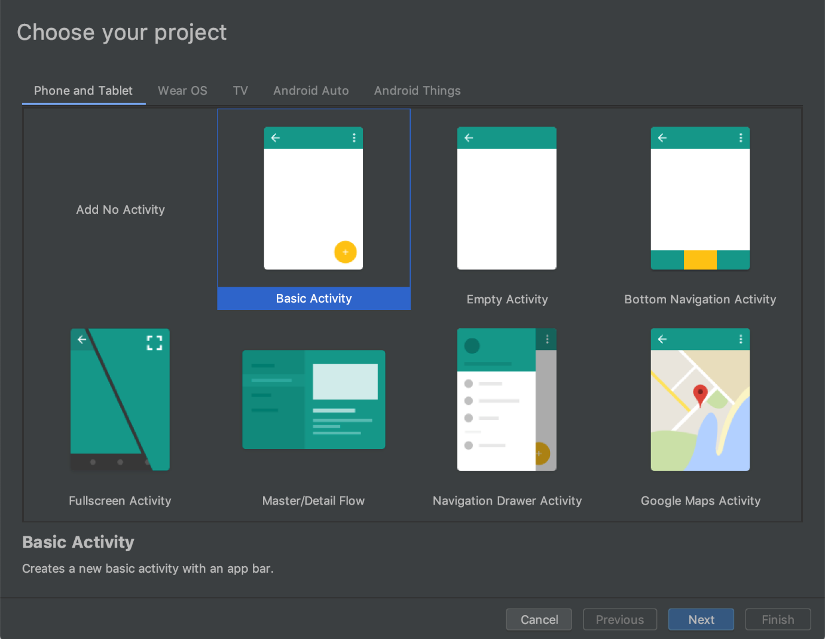

1. **Configure You Project according to your need.**

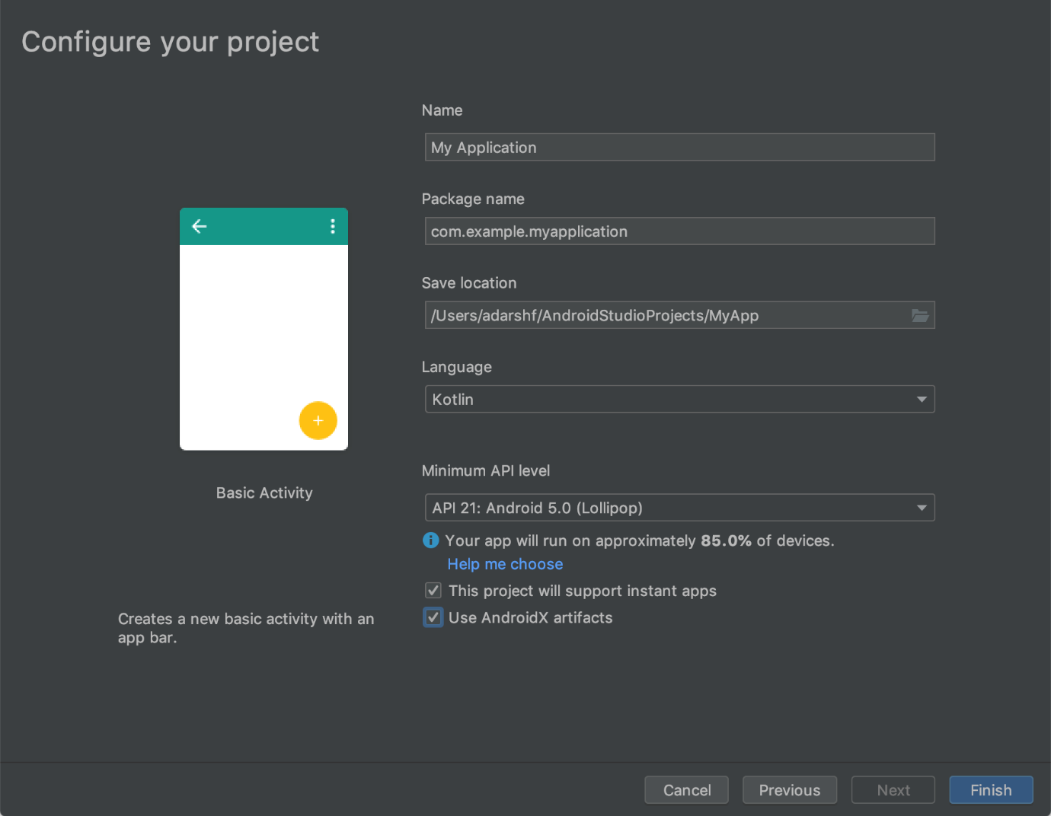

1. **After all this setup, You will see the big screen of Android Studio.**

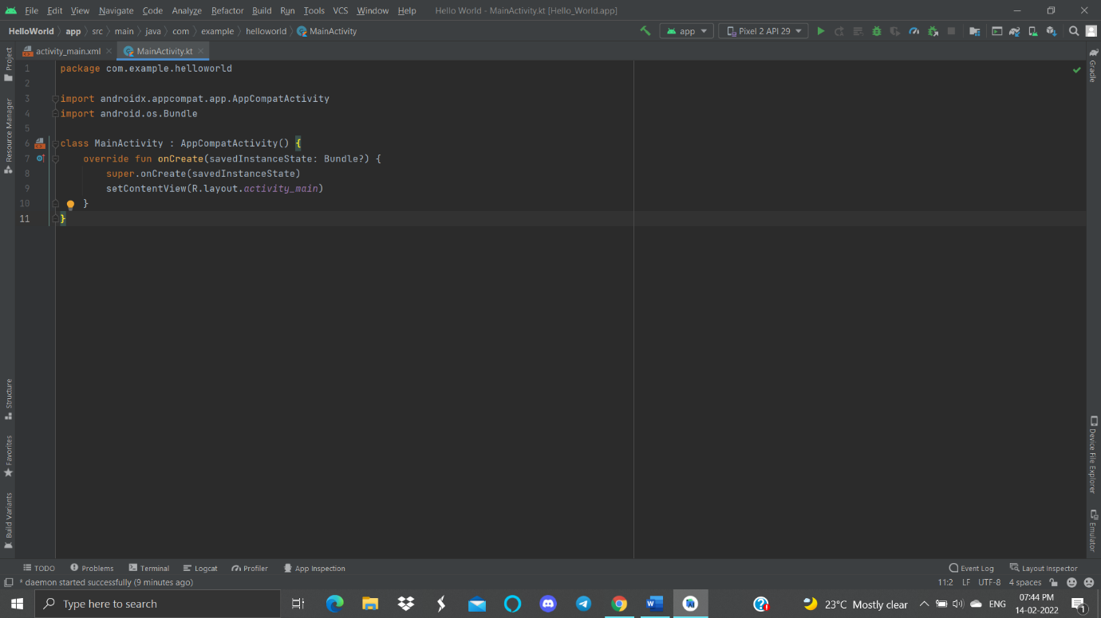

1. **I created my first project as “Hello World” lets run it on Emulator. (It is running on Pixel 2)**

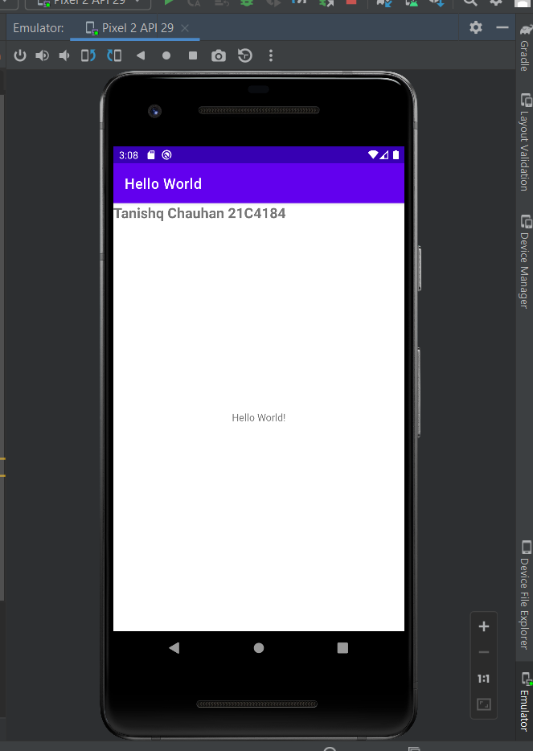

1. **Installed in Mobile via USB**

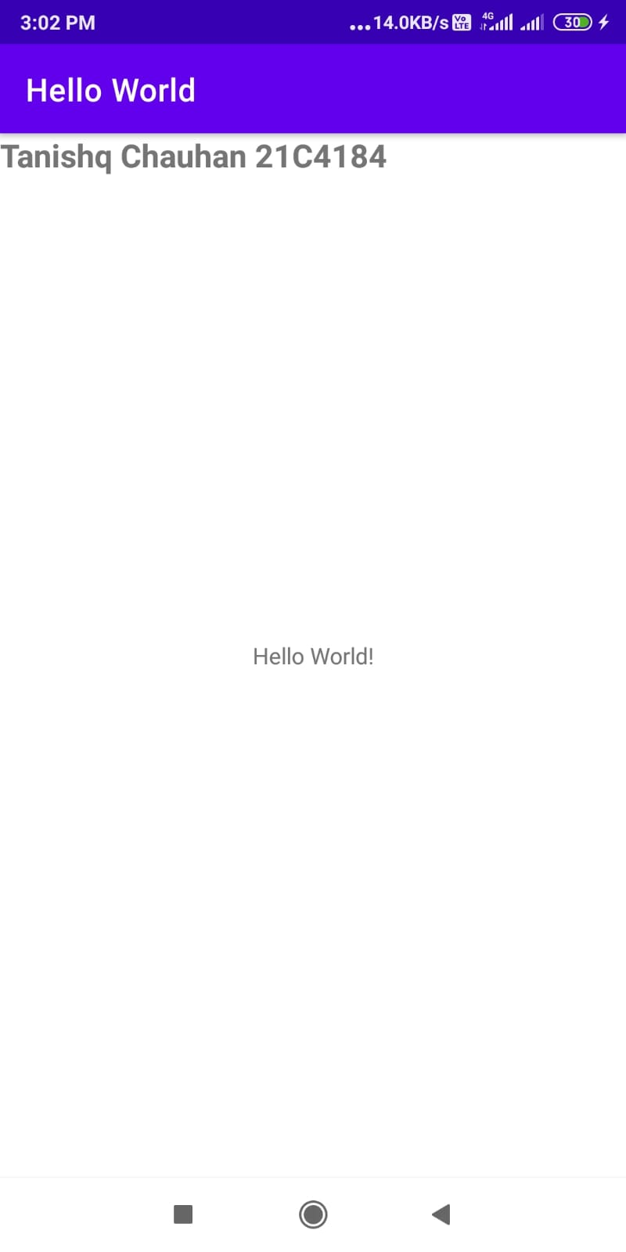

**Assignment-2**

**b) Develop an application which have name, mobile no, class and branch form with two button Submit and Reset.**

**c) Store above information in database.**

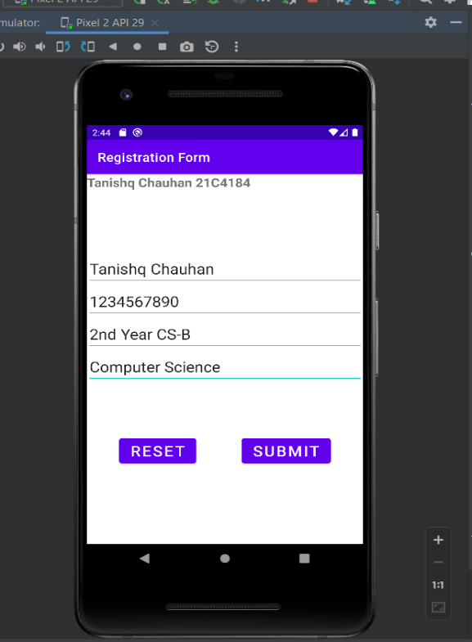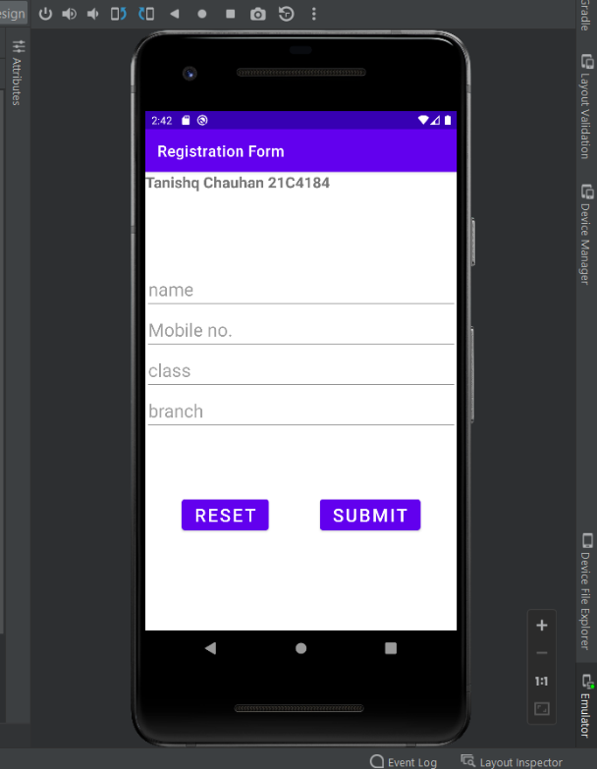

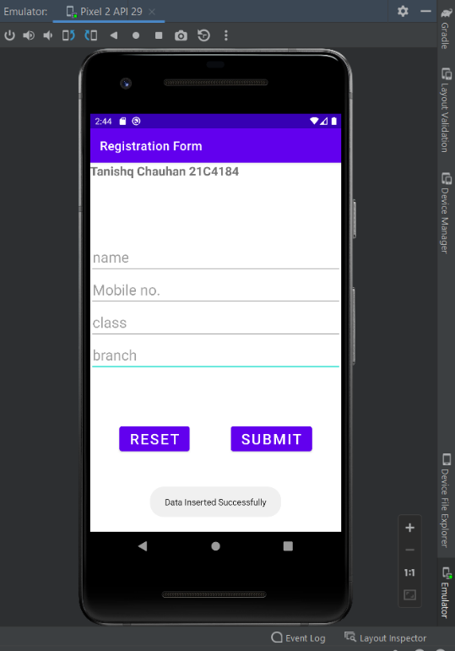

**Assignment-3**

**d) Develop an application of watch with alarm clock and stopwatch feature.**

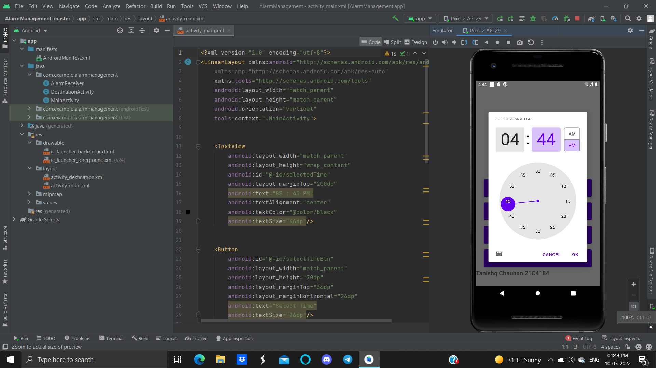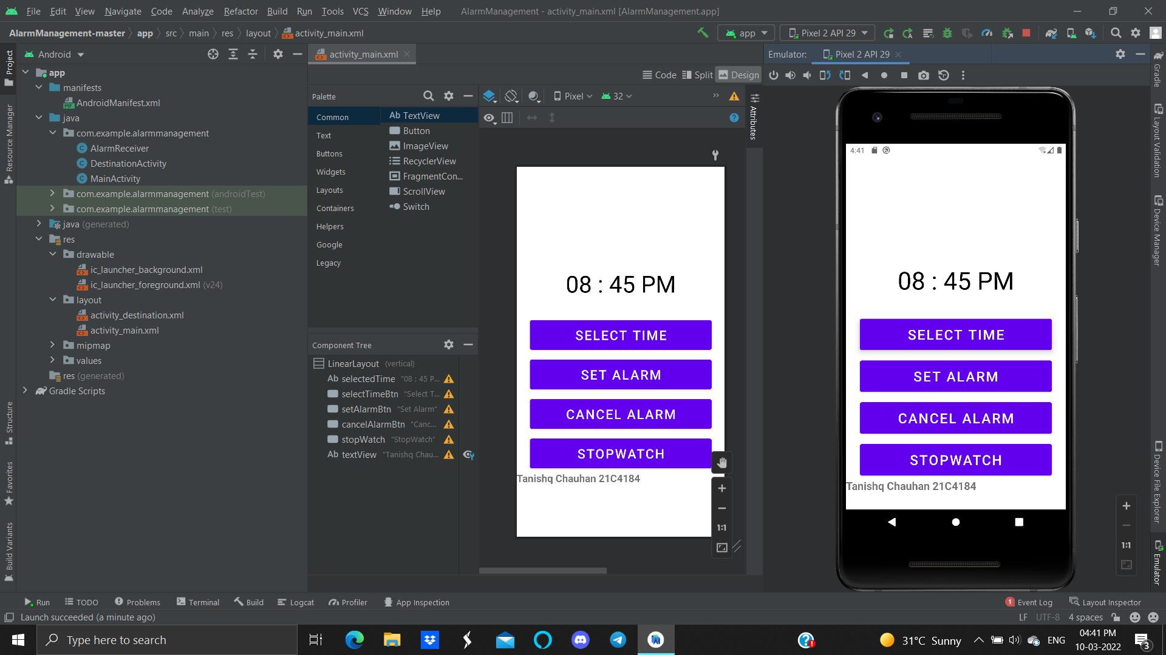

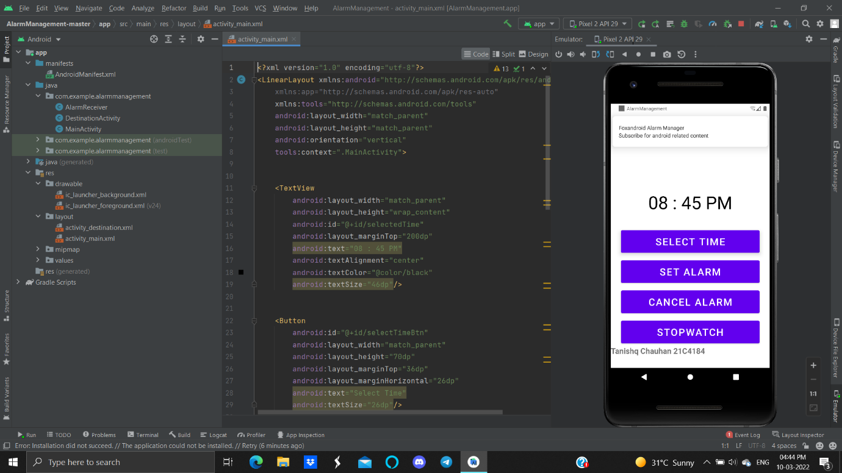

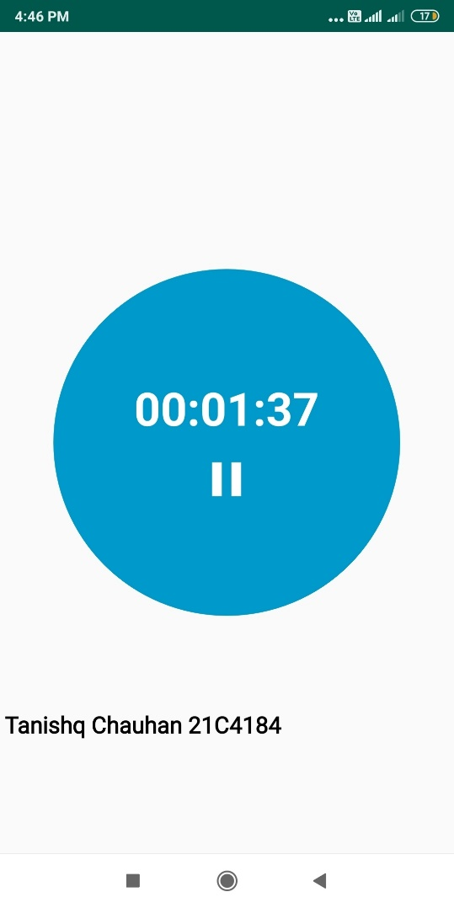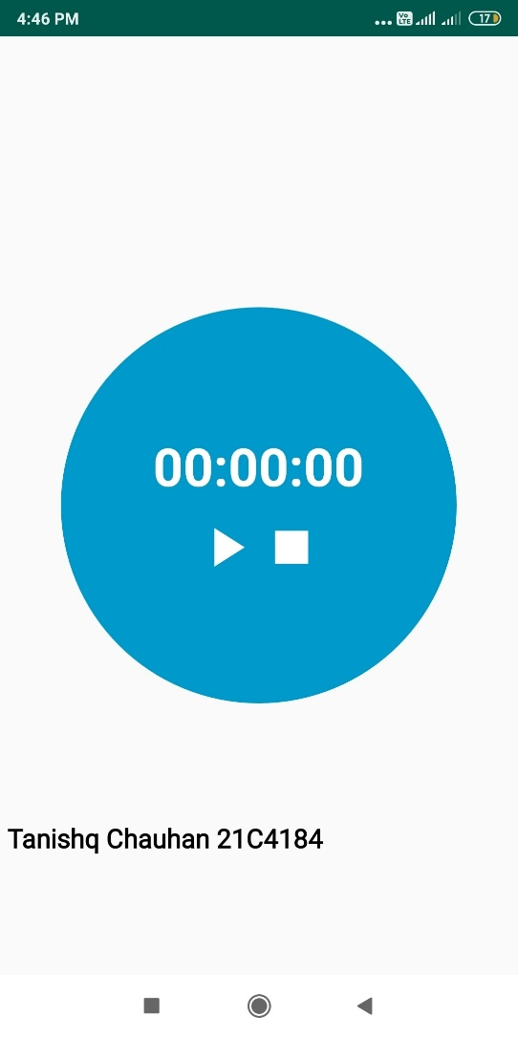

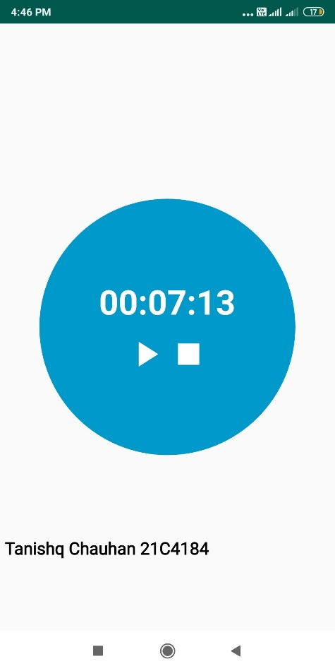

**e) Develop a native application for showing GPS location Coordinates and Direction Knowledge. (Distance of changing the coordinates.).**

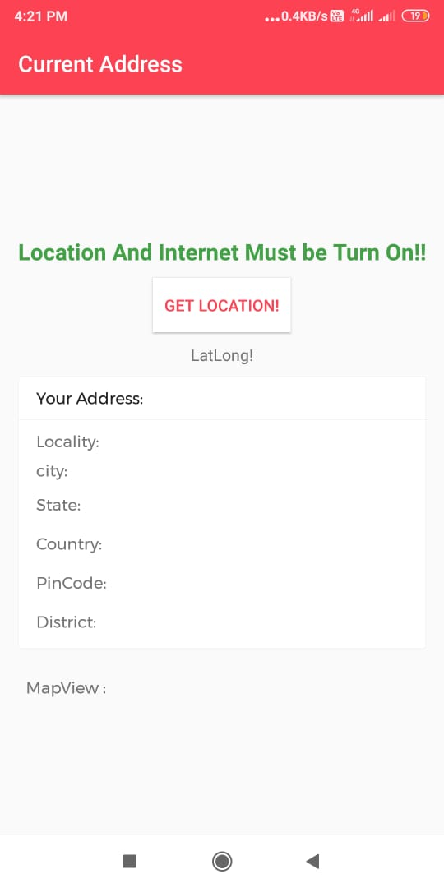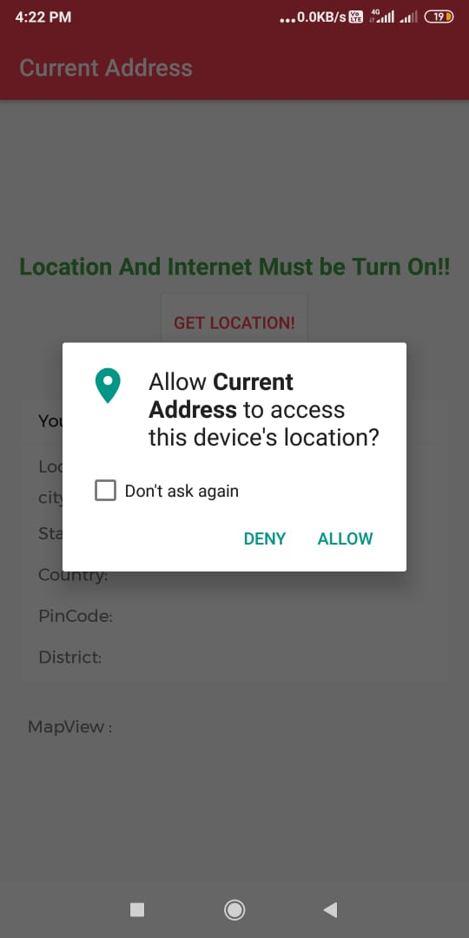

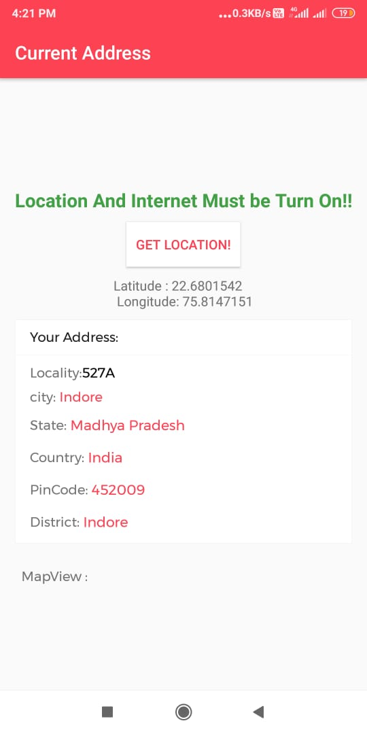

**Assignment-4**

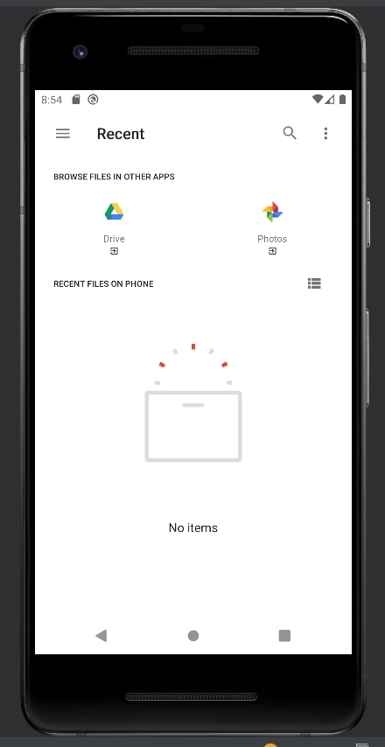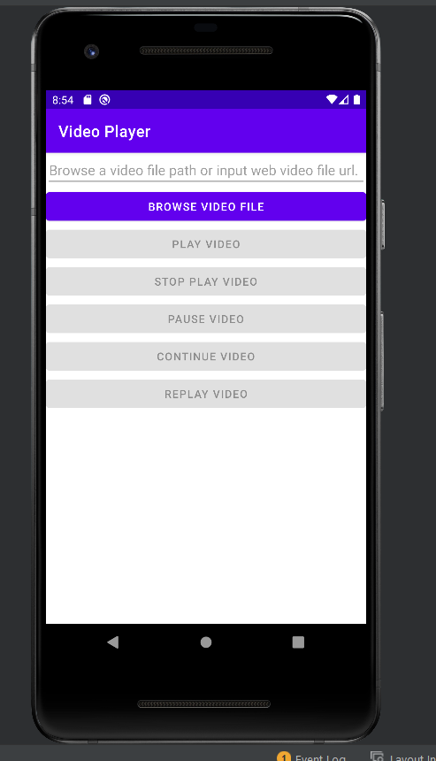**f) Implement an application of video player that reads and plays video files from the SD card. (Multithreading).**

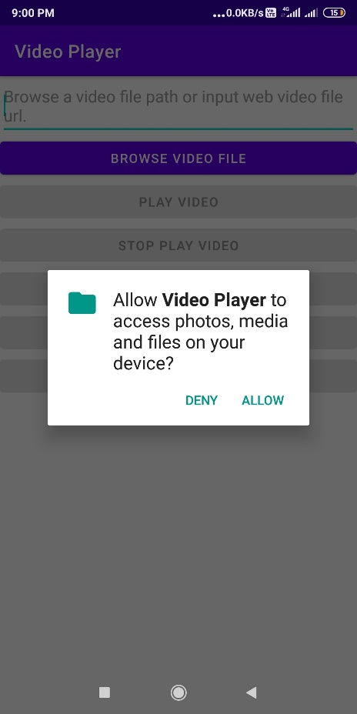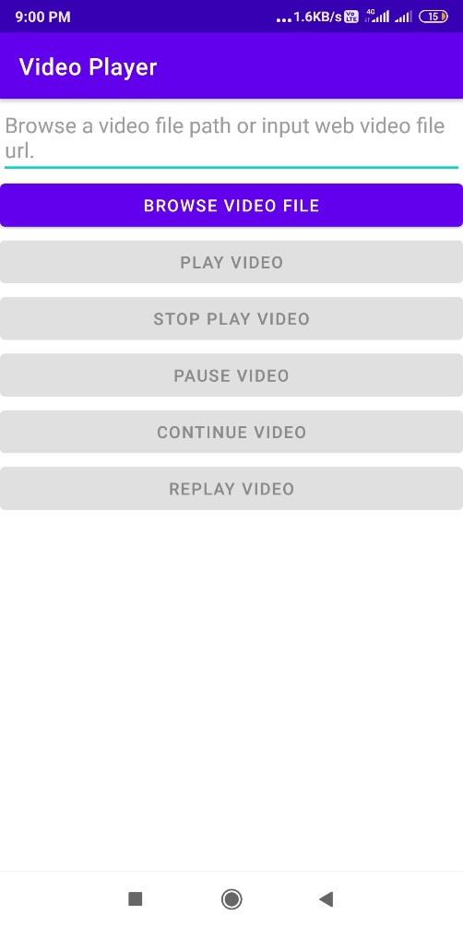

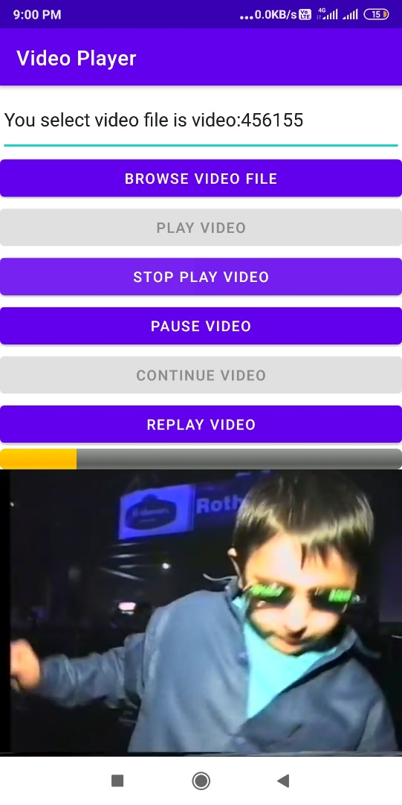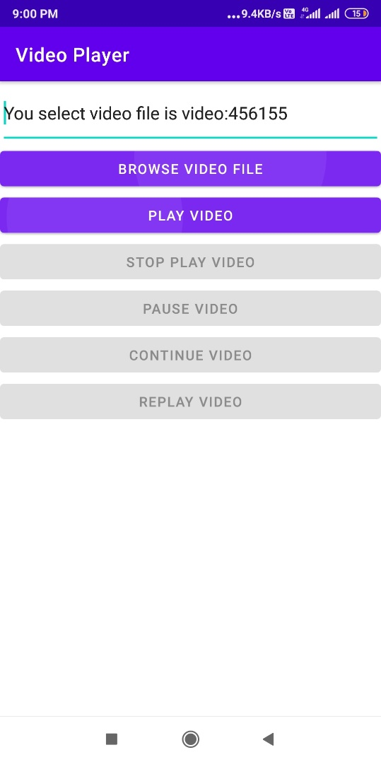

**g) Develop an application of news feed with alert (notification) on screen.**

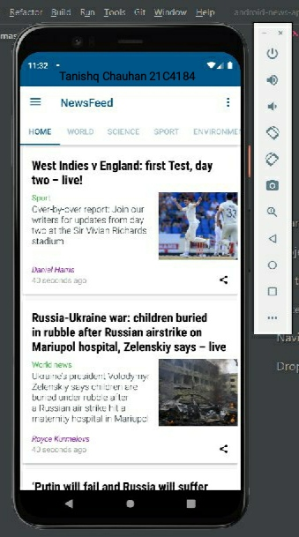

**Assignment-5**

**h) To Creating an app for step count and motion detection scenario.**

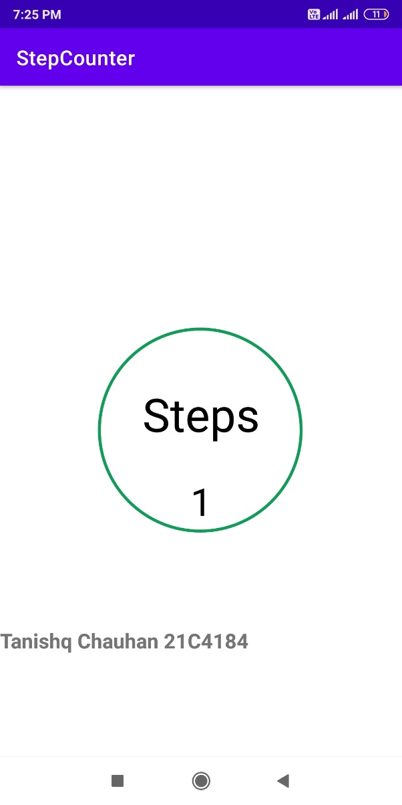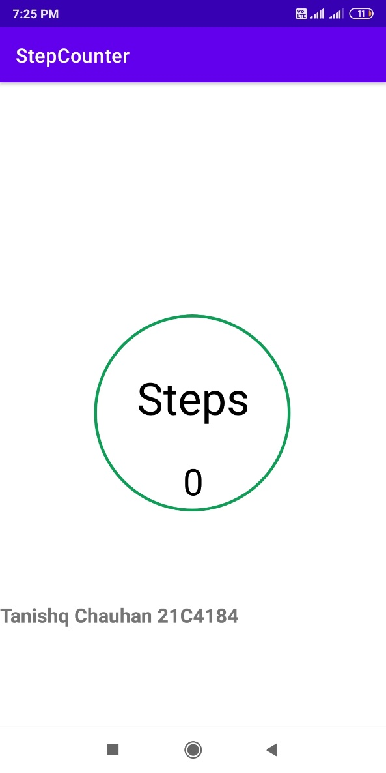**StepCounter**

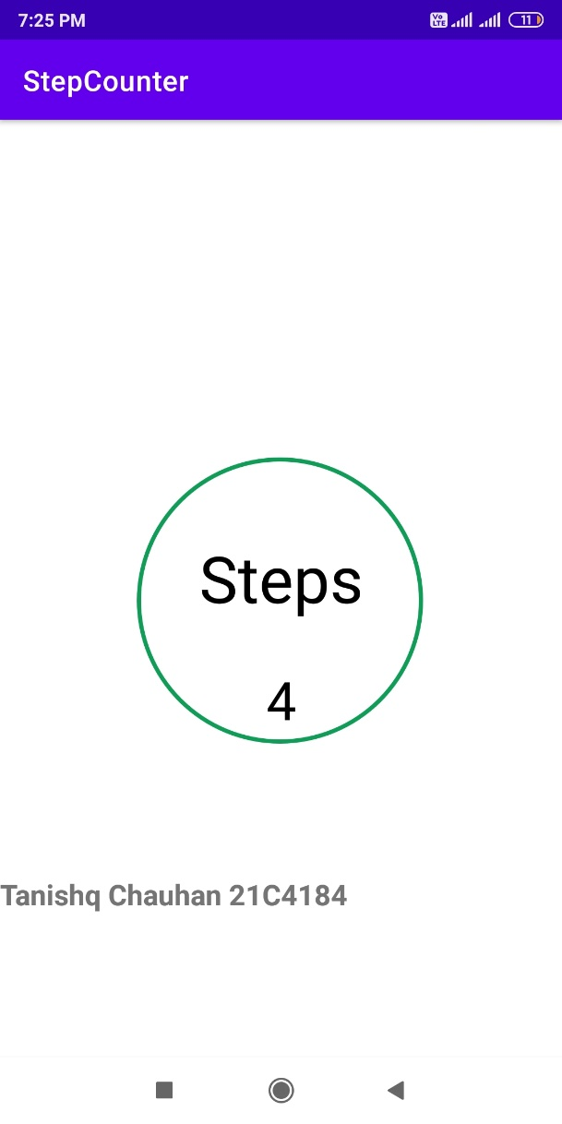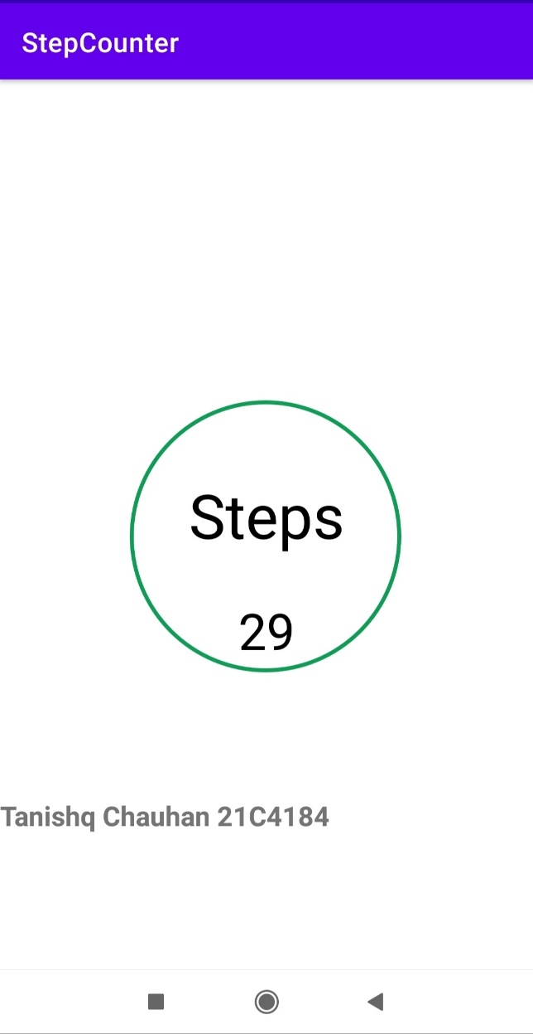

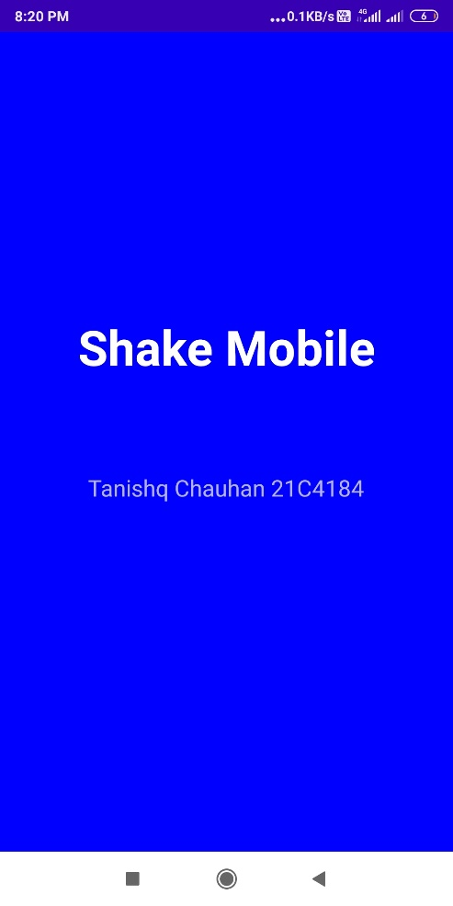**Motion Detection**

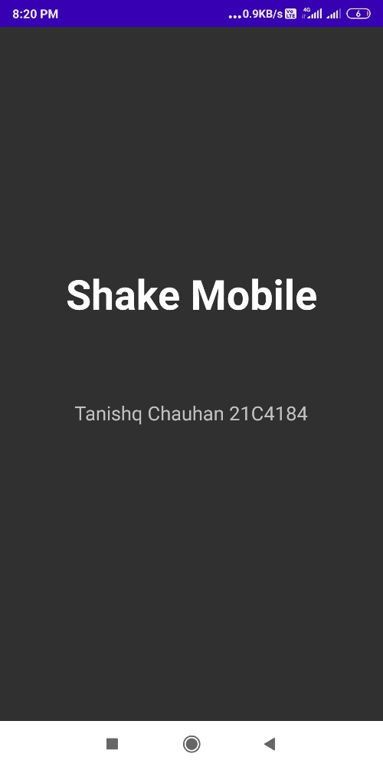

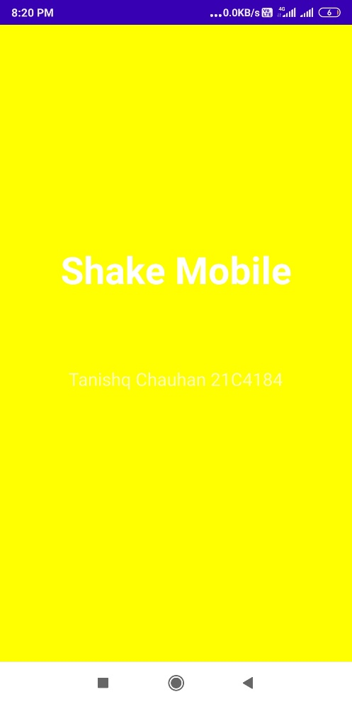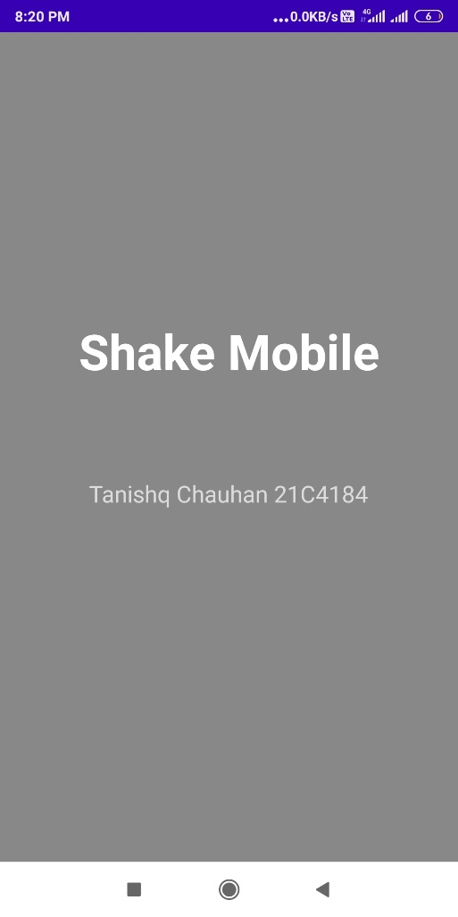

1. **Develop an application to show Environment data (Such as temperature, pressure, device temperature, and humidity).**

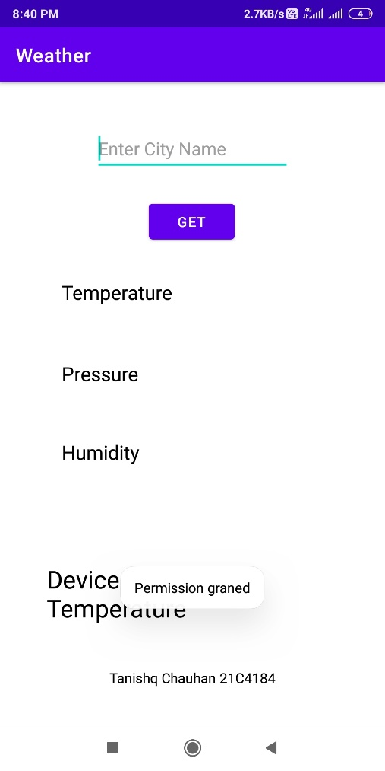

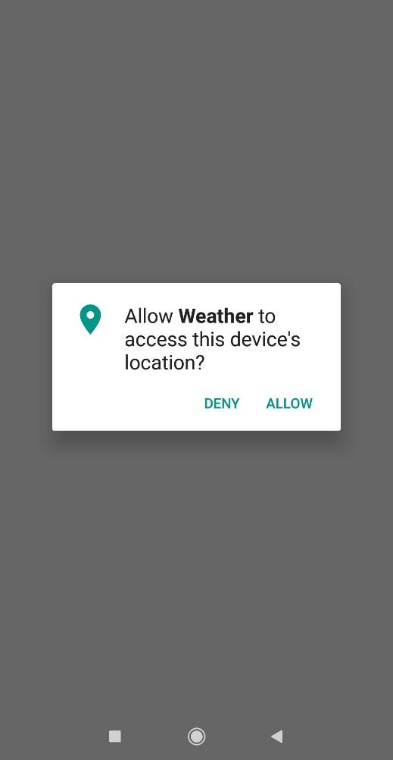

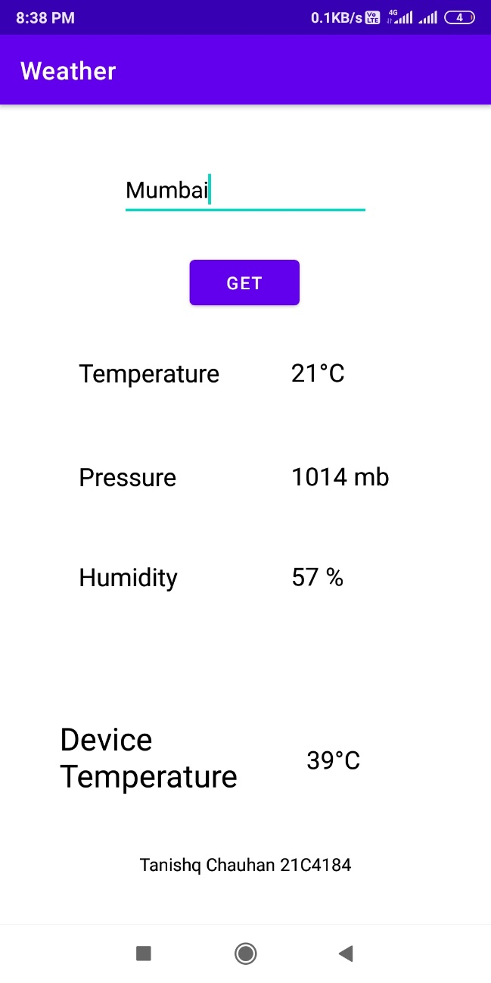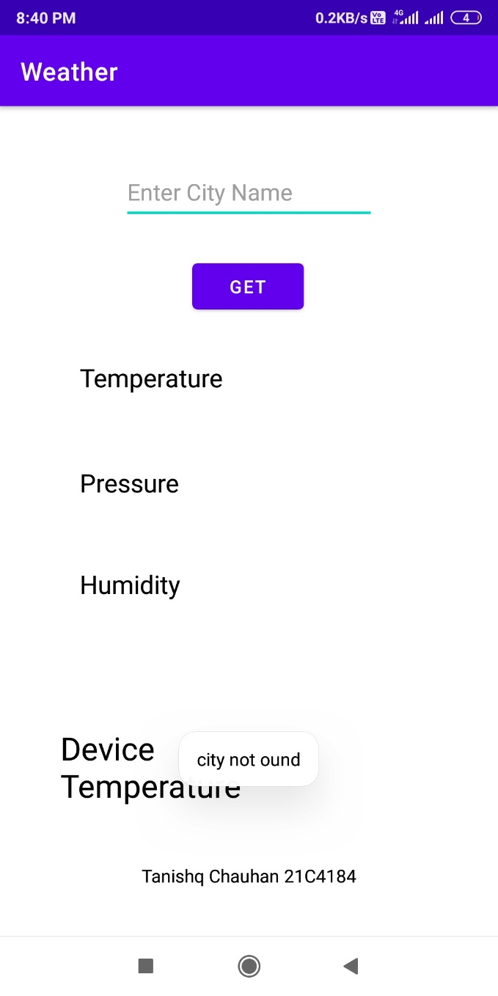

**Assignment-6**

**j) To Implement an app for makes transcript and notes from speech .(text to speech api)**

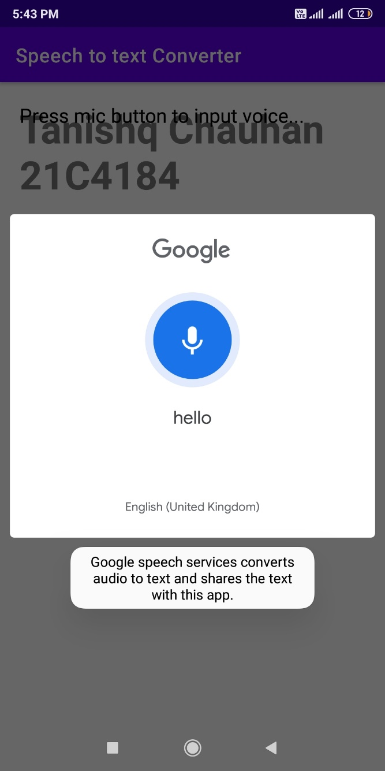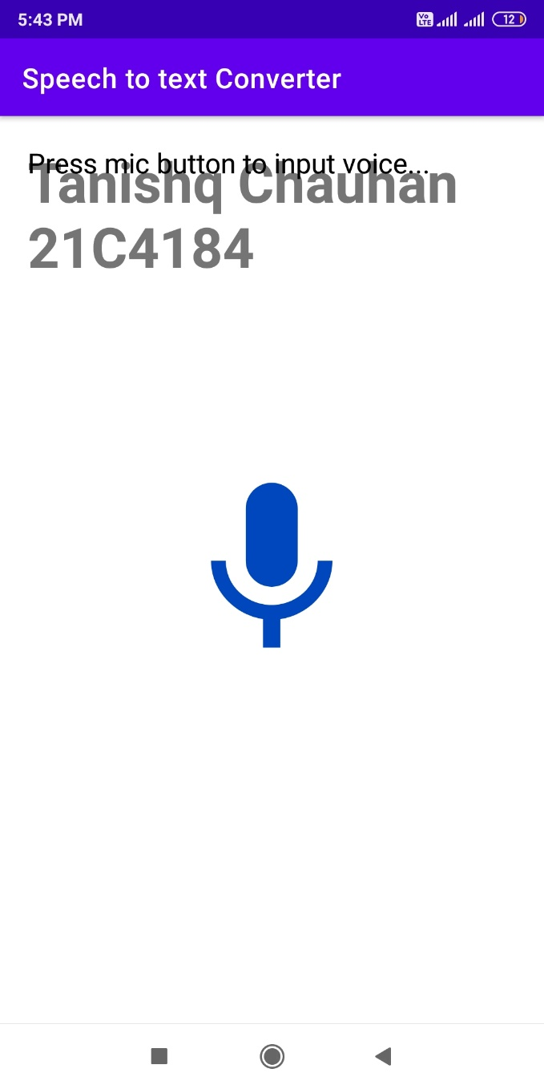

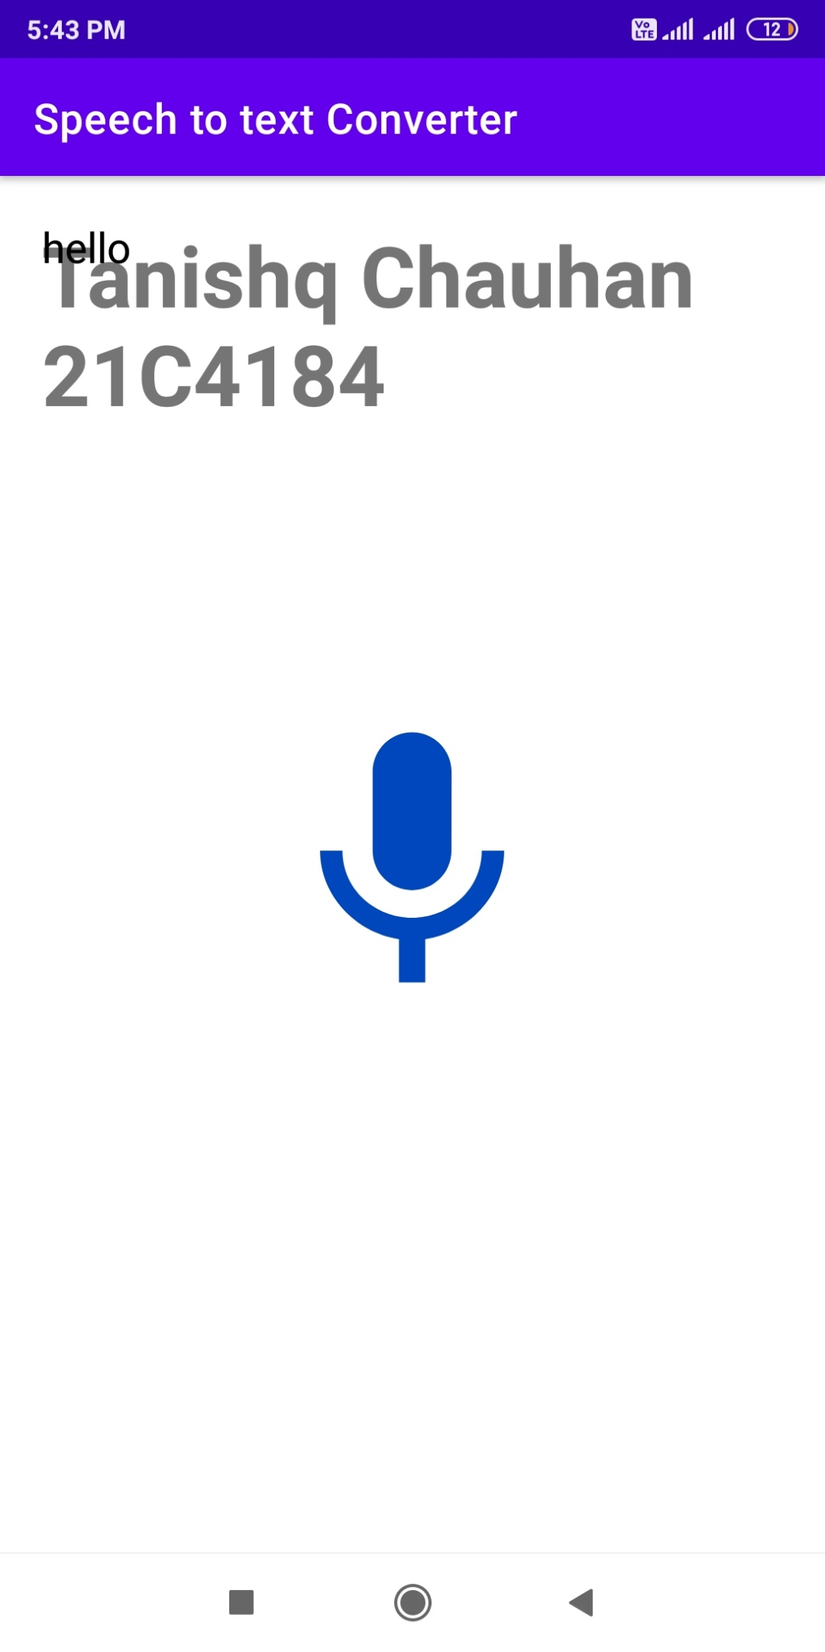

**k) To create an app for search wifi and Bluetooth device.**

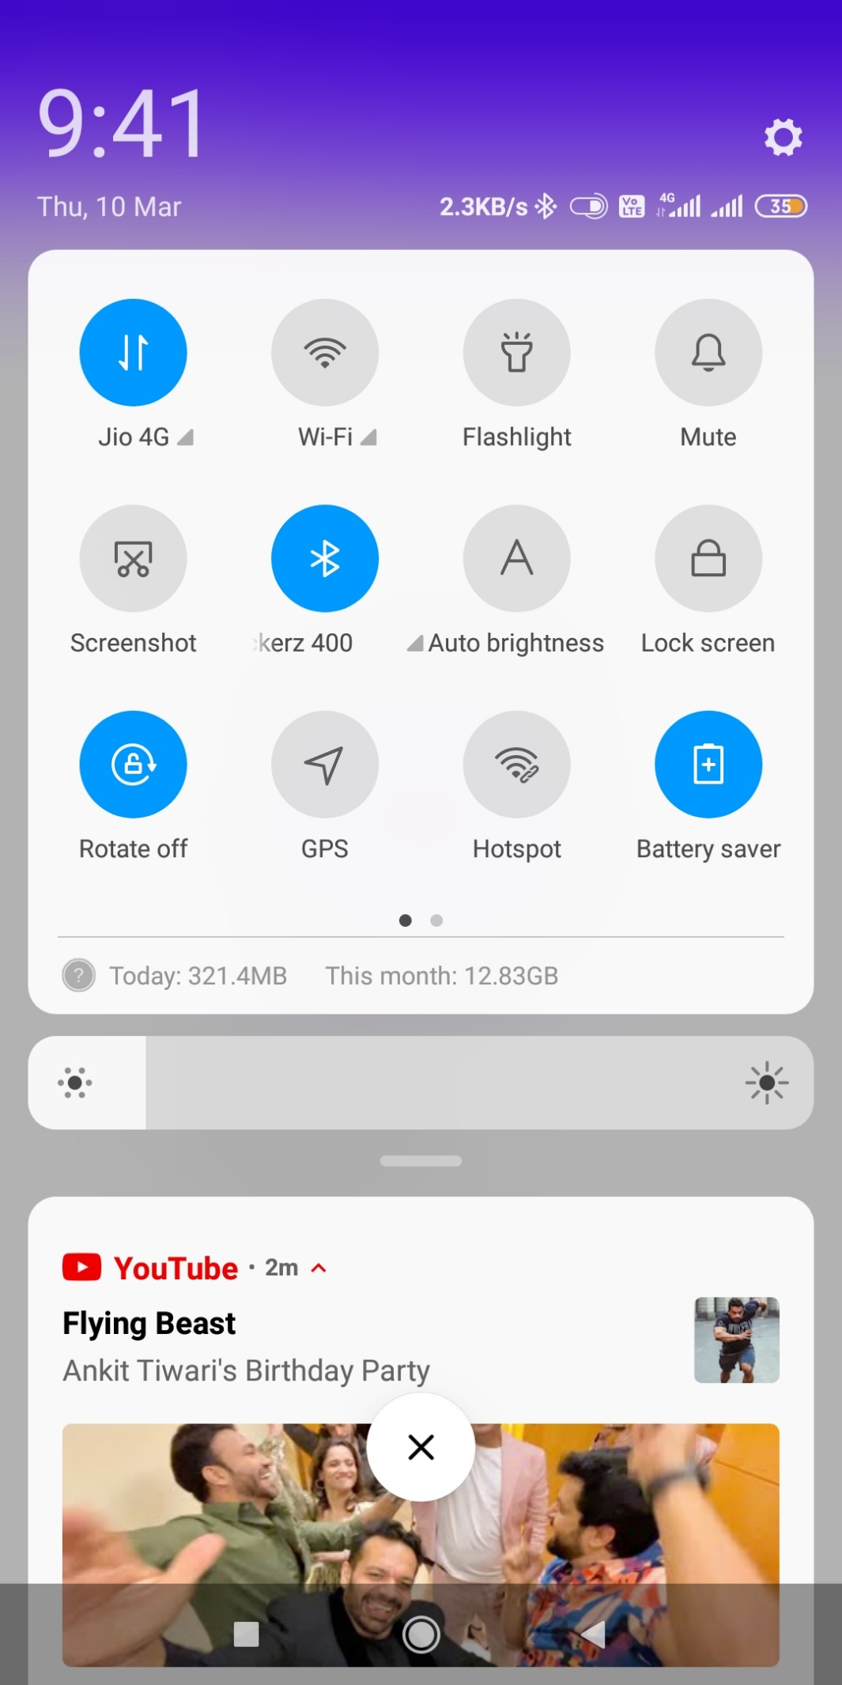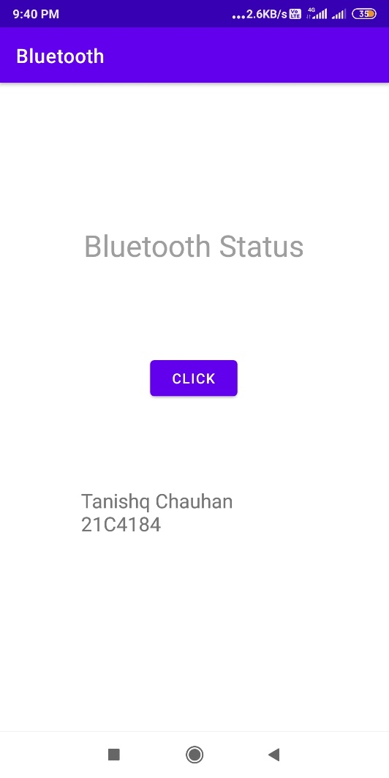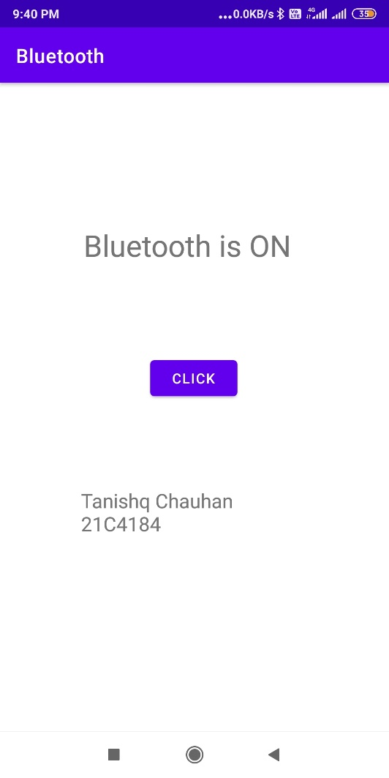

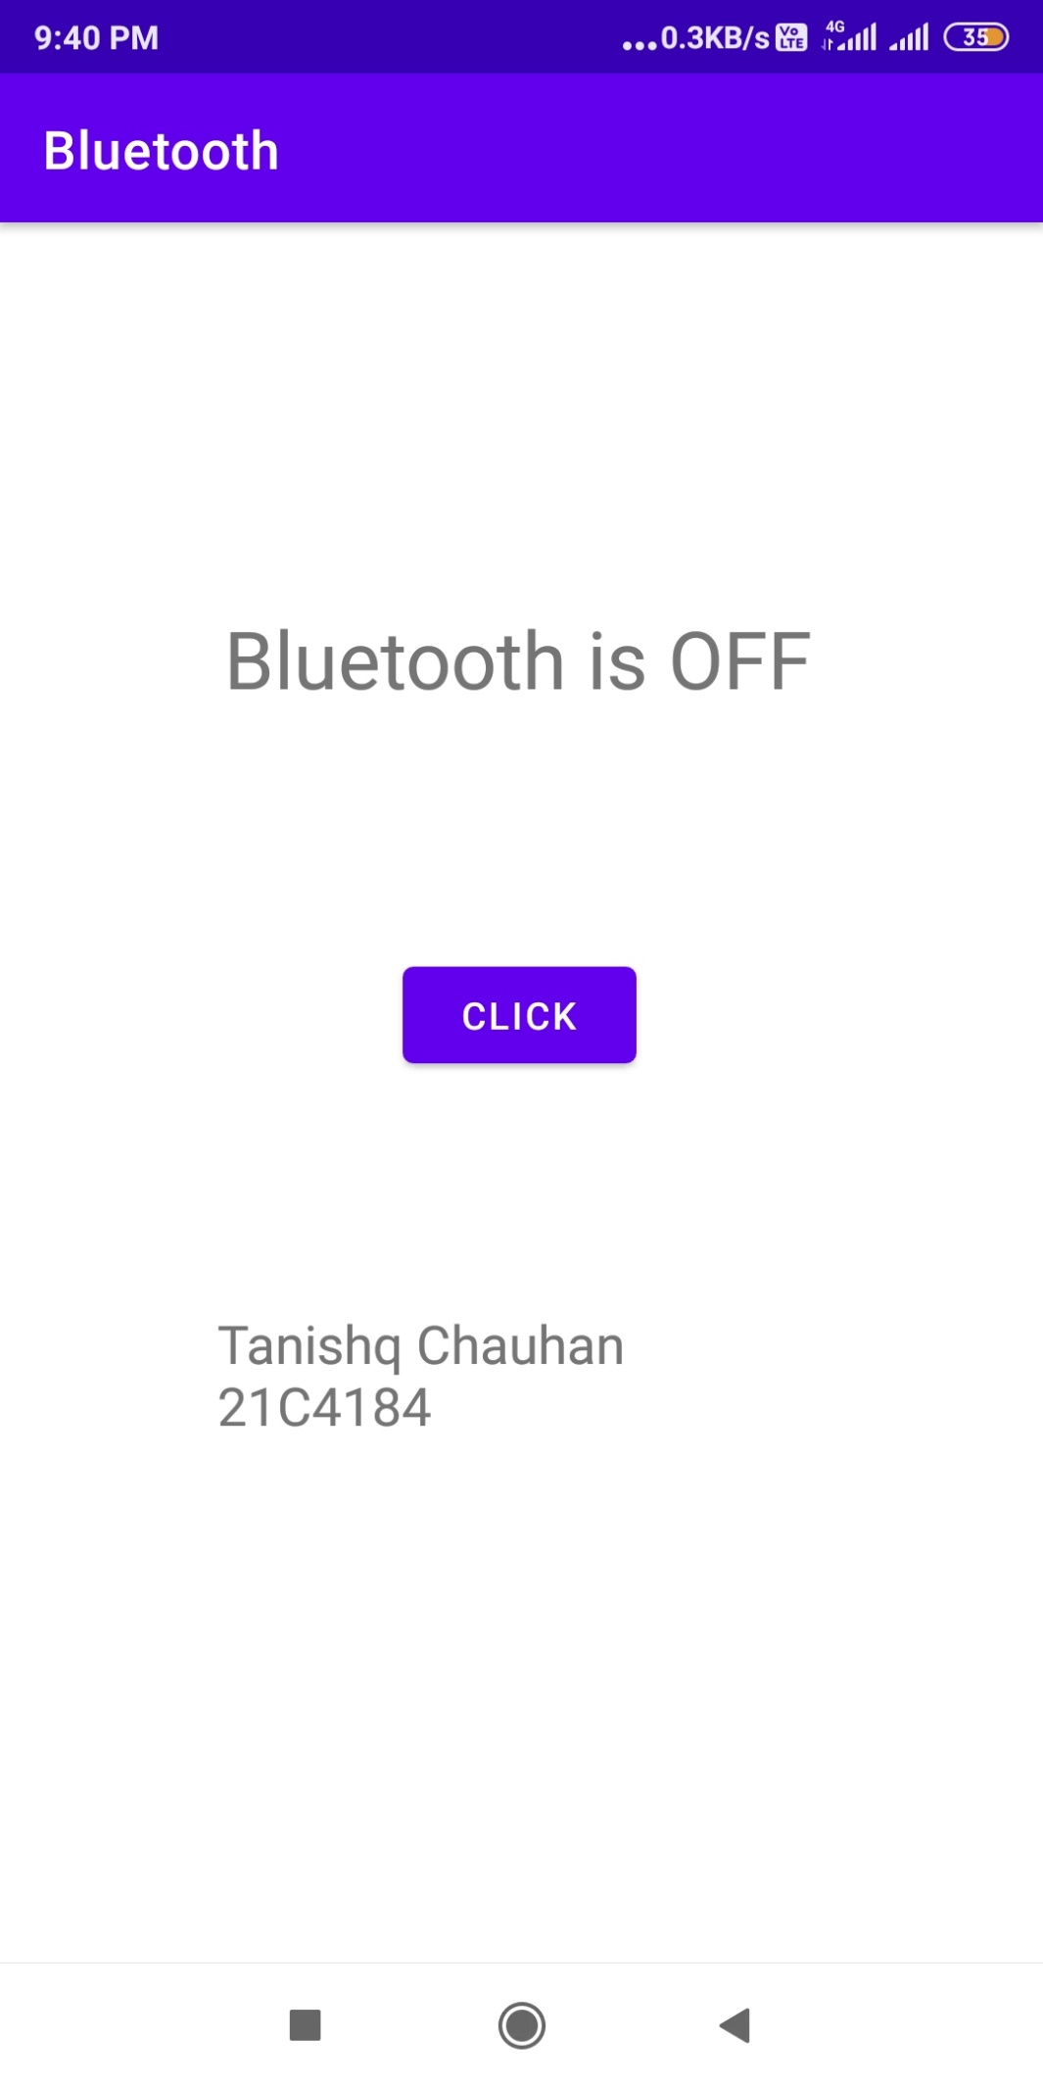

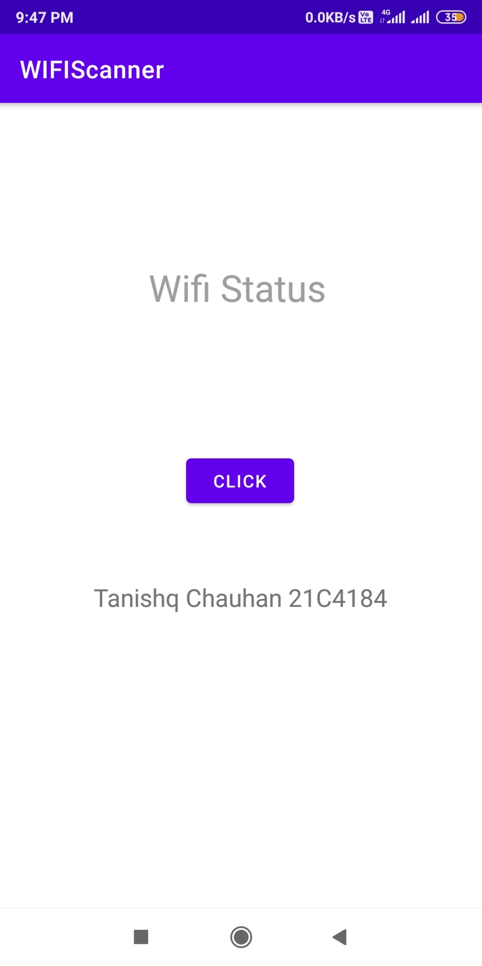

**Assignment-7**

**l) To develop an Android application based on problem identified by Student.**

**HAPPY PLACES**

**Have a Happy Journey with Happy Place**

**Problem Statement :-** Sometimes we think about a destination or someone told us but after some time we forget about that place when we want to plan a trip.

**Is it also happening with you?**

**Don’t Fear, “HAPPY PLACES” is here**

**Solution:-** To solve this problem, Here I am going to develop an app, in that, whenever you think or listen about a new place create a card/list and add the name of the place in the title with some description that you know or listen to to about the place. You can also add an image or as well as location. So after that whenever you plan a trip you don't have to wander.

**Have a HAPPY JOURNEY WITH HAPPY PLACES**

**Here I am adding some screenshots of the HAPPY PLACES below:**

**MainActivity**

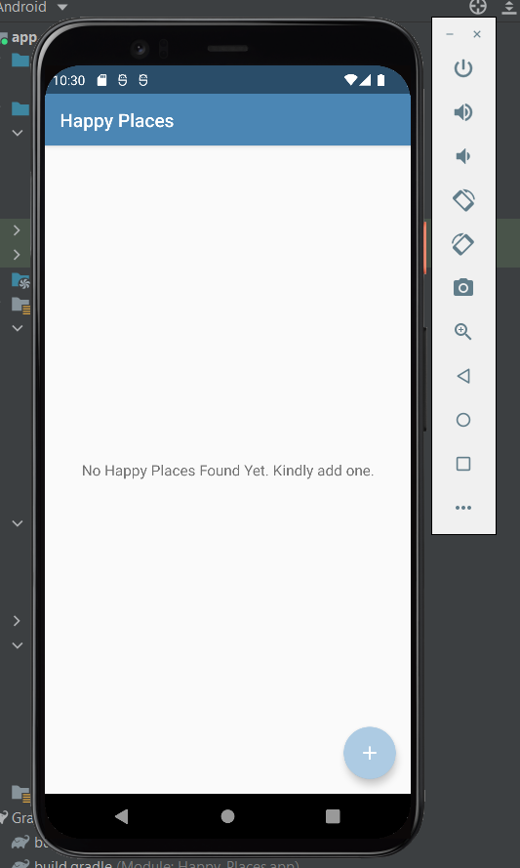

* This is the main activity page of the **HAPPY PLACE**.
* Where you can see all your **HAPPY PLACES**.
* You also have a **ADD** button here to direct you to **AddHappyPlaces** Activity.
* Where you can add you Happy Places.

**AddHappyPlace Activity**

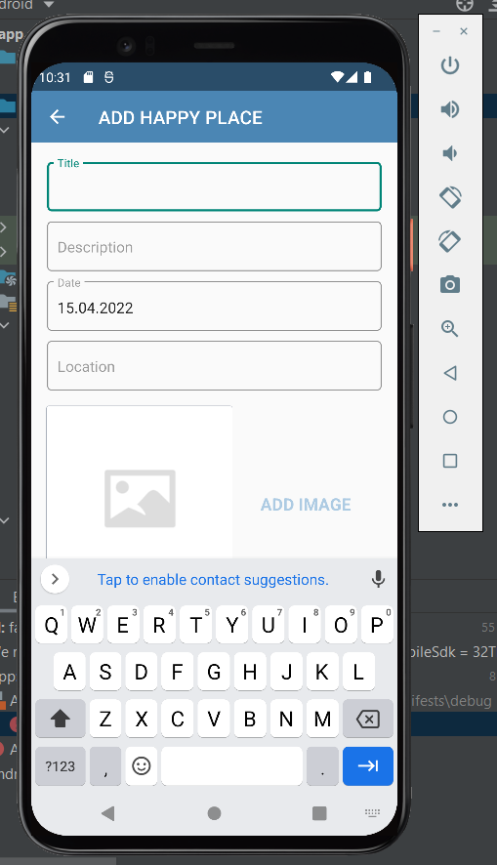

* This one is the **AddHappyPlace Activity** page.
* Here you can add your all the wishlisted Happy Place where you want to travel in your lifetime.
* There is some basic steps or fullfill the data to add a Happy Place.
* You can see all the required fields on the screen.

Do you want to see some of the Happy places?

So Lets see, which I already added on my Happy Place List.

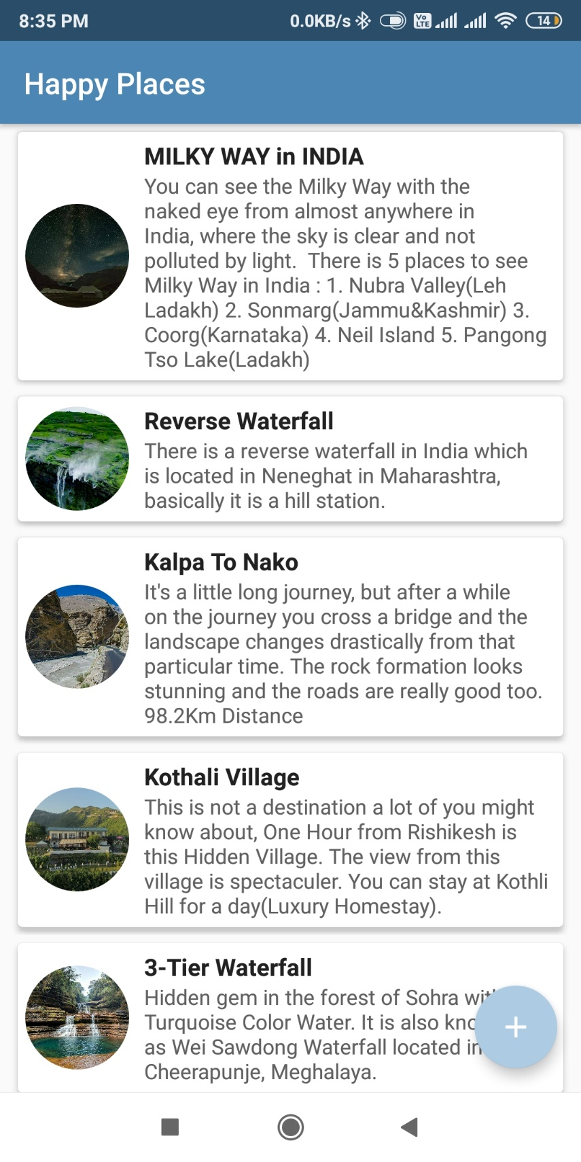

**Now, Lets create a HappyPlace for you.**

* Open the HappyPlace App
* Your will see the main page with your HappyPlaces.
* To Add New Happy Place Click on Add button to direct on AddHappyPlace Activity.

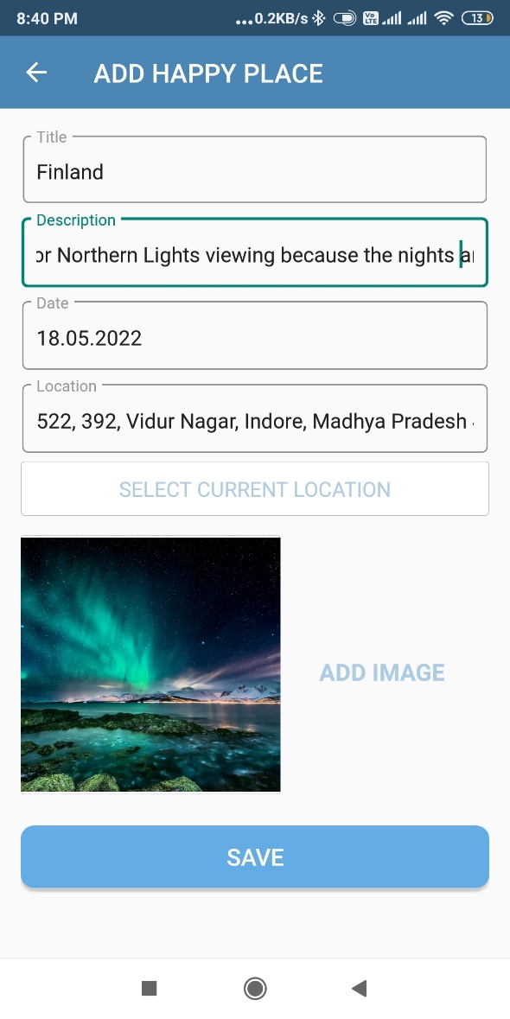

* **Title :** Name of the place/ or title.
* **Description :** Some details about the place.
* **Date :** On which date you see or some told you about the place.
* **Location :** Place where it is located.
* **Images :** Display Picture image. (Gallery/Camera)
* When we click on the **SAVE** button, we again redirect on the **MainActivity** Page where all the **HappyPlaces** are there.

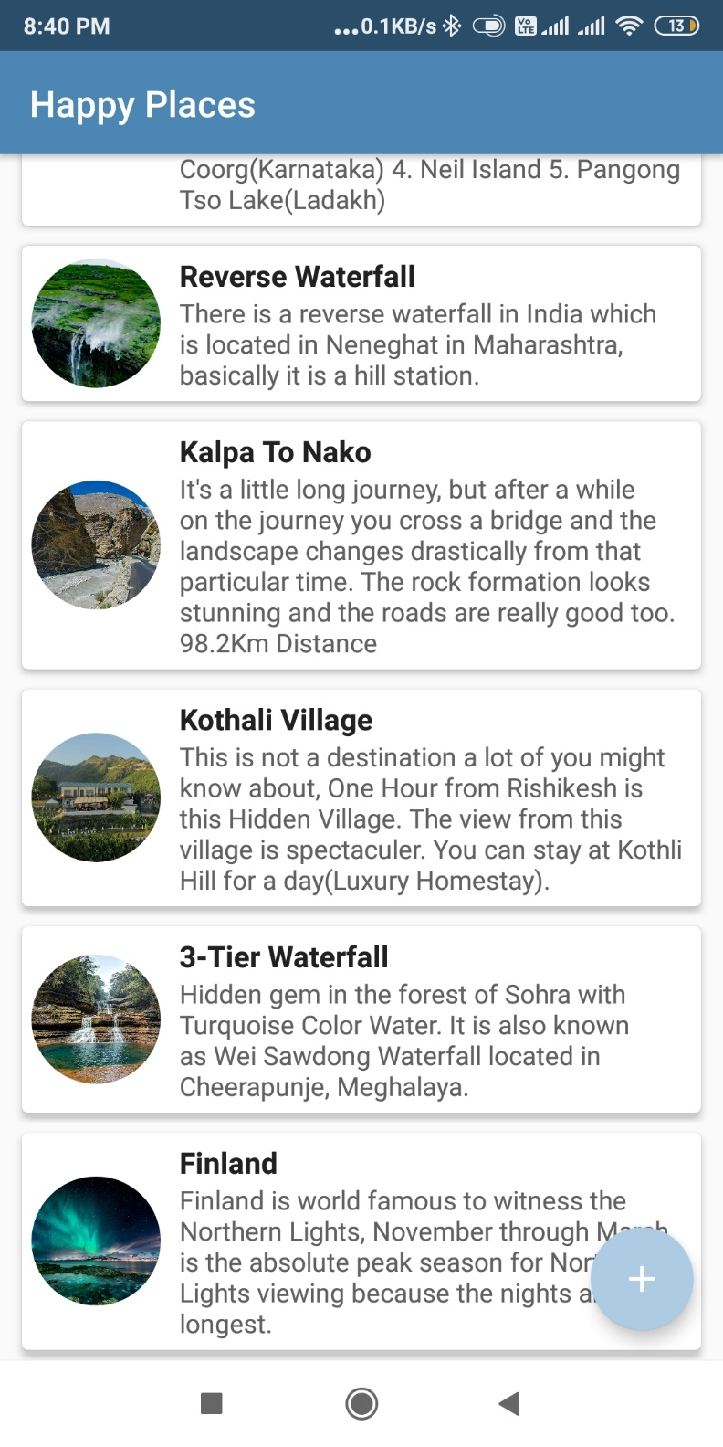

* We can also **update** this page by just right swipe.

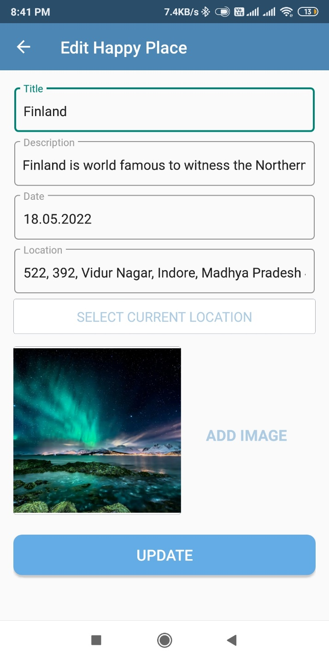

* We can also **DELETE, HAPPY PLACES** by just left swipe.

**HappyPlaceDetail Activity**

* Here you can see the **details** of the Happy Place which you added while creating or adding a new Happy Place in your list.

